Conversational Agents

Source: https://people.ischool.berkeley.edu/~dbamman/nlp20_slides/23_dialogue.pdf
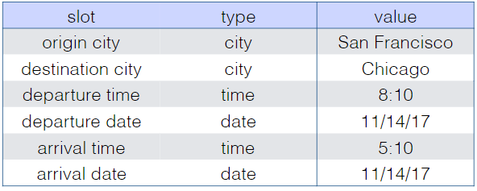
Conversational bots
- Task-oriented
- Conversational
- Frame-based
  - Collection of slots with possible values
  - Domain classification
  - Intent determination
  - Slot filling
- Model speaker-specific information using personas and addressee by combining user representation and addressee
- Limitation: seq2seq models maximize conditional probability which may result in generic answers that are valid in any situation
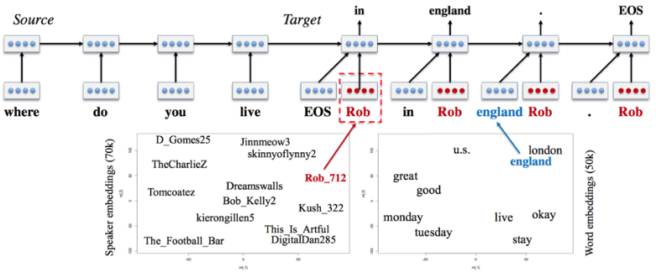
Evaluation
- Perplexity
- BLEU score: closeness of held-out and generated response (n-gram overlap)
- Limitation: many valid responses unlike machine translation
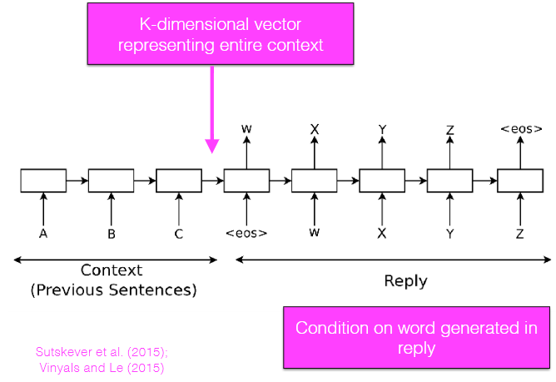
Encoder-decoder framework
- Encode context into vector and decode new sentence from embedding
  - Language modeling: left context → word
  - Conversation: left context + dialogue context → word
  - Machine translation: left context + full text of source → word
- Datasets: OpenSubtitles

